**HW 4 Tree**

1. In the rooted tree T(with root a), find the parent of c, the children of g, the sibling of h, all ancestors of e, all descendants of b, all internal vertices, and all leaves. What is the subtree rooted at g?

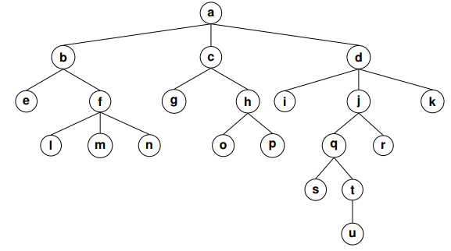

a) Which vertex is a root? a .

b) Which vertices are internal? a,b,c,d,f,h,j,q,t .

c) Which vertices are leaves? e,I,m,n,g,o,p,f,I,u,k .

d) Which vertices are children of j? q,r .

e) Which vertex is the parent of h? c .

f) Which vertices are siblings of o? p .

g) Which vertices are ancestors of m? b,a .

h) Which vertices are descendants of b? I,m,n .

i) Draw the subtree of the tree that is rooted at c

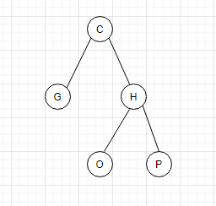

1. Which of the rooted trees shown below are **balanced tree**

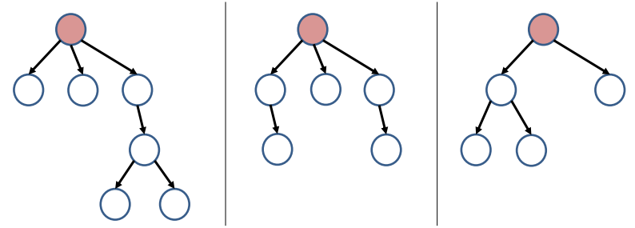

Answer: Figure 2 and Figure 3 are balanced tree .

1. **Build the binary search tree** for the numbers 20,15,17,28,22,26,10,13,16,8,40,45,33,36,48,30,9,3,19,32,29,18

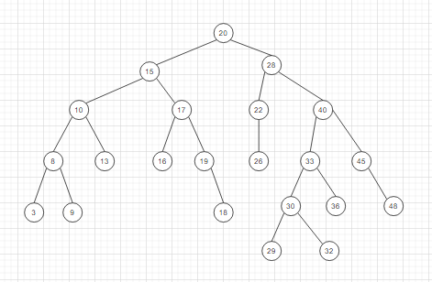

1. **Draw a decision tree** The Five-Coins Puzzle. In this puzzle we have five coins C1, C2, C3, C4, C5 that are identical in appearance, but one is either heavier or lighter that the others. The problem is to identify the bad coin and determine whether it is lighter or heavier using only a pan balance and comparing the weights of two piles of coins.

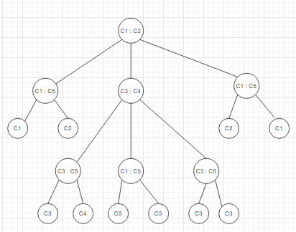

1. **Use Huffman coding** to encode these symbols with given frequencies: a : 2, b : 3, c : 7, d : 8, e : 12?

|  |  |
| --- | --- |
|  | Encoding:  a 1 , 1 , 1  b 1 , 1 ,0  c 1 , 0  d 0 , 1  e 0 , 0 |

* 1. 11011101 bad
  2. 010011101 dead
  3. 0100101110100 decade
  4. 1100001 ded

1. Determine the order in which a **preorder, inorder and postorder traversal** visits the vertices of the given ordered rooted tree.

|  |  |
| --- | --- |
|  | Preorder  A,b,d,e,f,g,c  Inorder  d,b,f,e,g,a,c,  Postorder  d,f,g,e,b,c,a |

1. Determine the order in which a **preorder, inorder and postorder traversal** visits the vertices of the given ordered rooted tree.

|  |  |
| --- | --- |
|  | Preorder  a,b,d,e,i,f,j,m,n,o,c,f,g,h,k,I,p  Inorder  d,b,i,e,m,j,n,o,f,c,g,k,h,p,l  Postorder  d,i,m,n,o,j,e,b,f,g,k,p,l,h,c,a |

1. Represent the expression by using **expression trees**
2. (x + xy) + (x/y)

Write this expression tree in

* + 1. Prefix notation

+, +, x, *, x, y, /, x ,y

* + 1. Postfix notation

x, x, y, *, +, x, y, /, +

* + 1. Infix notation

x + x y + x/y

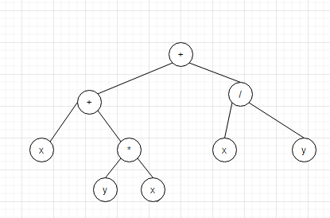

1. x + ((xy + x)/y)

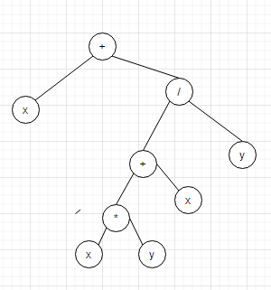

Write this expression tree in

1. Prefix notation

+, x, /, +, *, x, y

1. Postfix notation

x, x, y, *, x, +, y, /, +

1. Infix notation

x + x y + x / y

1. Draw **expression tree** of prefix expressions to represent the following expressions:
2. -∗ 2/8 4 3

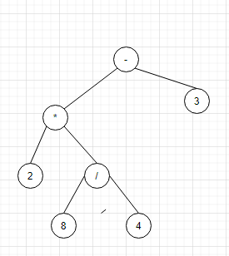

(2*(8/4))-3

What is the value of each of these prefix expression

1. 1
2. 1
3. ↑ − ∗ 3 3 ∗ 4 2 5

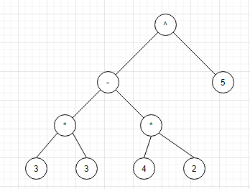

((3*3)-(4*2))^5

1. Use **depth-first search and breadth-first search** to produce a spanning tree for the given simple graph.

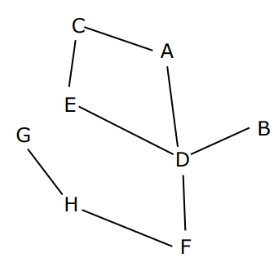

a. Find a breadth-first search starting with F b. Find a breadth-first search starting with C.

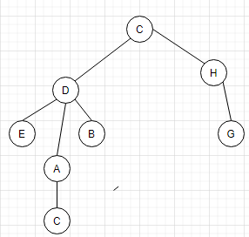

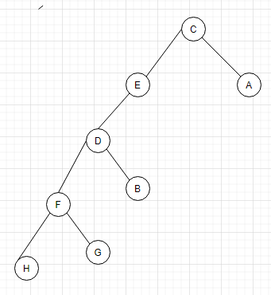

1. Use backtracking to try to find a coloring of each of the graphs using three colors.

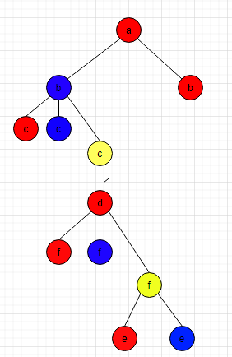 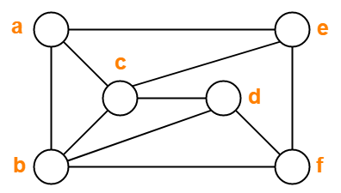

1. 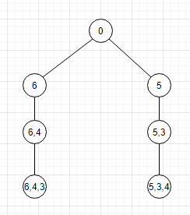Apply backtracking to solve the following instance of the subset sum problem: S = {3,4,5,6} and W=13

6,4,3 Sum = 13

5,3,4 Sum = 12

1. Find minimum spanning trees for the following graph. Use Kruskal’s algorithm and Prim’s algorithm starting at vertex a. Indicate the order in which edges are added to form each tree.

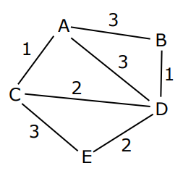  

Kruskal’s algorithm Prim’s algorithm

|  |  |  |  |  |
| --- | --- | --- | --- | --- |
| (A,C) | 1 |  | (A,C) | 1 |
| (B,D) | 1 |  | (C,D) | 2 |
| (C,D) | 2 |  | (D,B) | 1 |
| (E,D) | 2 |  | (D,E) | 2 |
|  |  |  |  |  |
| total | **6** |  | total | **6** |
|  |  |  |  |  |
|  |  |  |  |  |
|  |  |  |  |  |
|  |  |  |  |  |